Ideation Phase

Define the problem statement

Date | 02 NOVEMBER 2025
Team ID | NM2025TMID02363
Project Name | Laptop Request Catalog Item
Maximum Mark | 2 Marks

Customer Problem Statement
Employees face challenges when requesting laptops for work due to manual request processes.These delays lead to inefficiencies, miscommunication, and incomplete tracking of requests.
There’s also no dynamic behavior in the form to guide users, causing incorrect or incomplete data submission.An automated Service Catalog Item with smart form behavior and approval tracking would ensure faster, error-free requests and improved user experience.
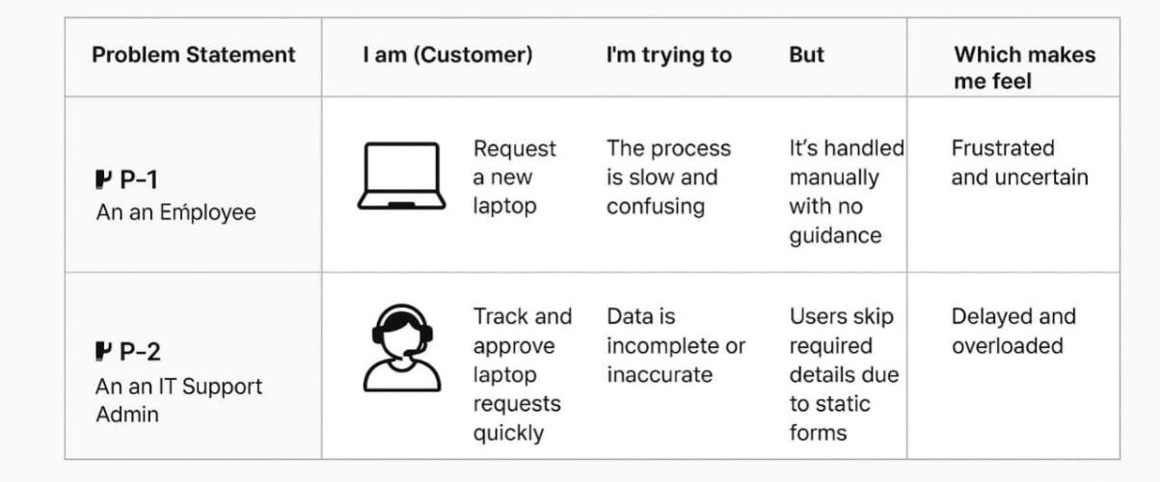
Problem Statement PS-1
As an employee, I am trying to request a laptop needed for my work, but the current process is manual and time-consuming. Because there is no automated form or clear guidance, I often make mistakes or forget required details.
This makes me feel frustrated and anxious about whether my request will be approved on time. I need an easy, dynamic service catalog form that guides me and ensures all necessary information is filled correctly.
Problem Statement PS-2
As an IT Support Admin, I want to process laptop requests efficiently, but due to incomplete or incorrect user data, approvals get delayed. Because the form lacks validation and dynamic behavior, I spend extra time clarifying missing information.
This makes me feel overwhelmed and reduces overall service efficiency. I need an automated system with UI policies and actions to validate data, speed up processing, and maintain accurate records.

Project Design Phase
Proposed Solution
Date | 02 NOVEMBER 2025
Team ID | NM2025TMID01366
Project Name | Laptop Request Catalog Item
Maximum Mark | 2 Marks

Proposed Solution Template
S.N0 | Parameter | Description
1 | Problem Statement (Problem to be solved) | Employees face delays and confusion when requesting laptops due to a manual and static request process. There is no dynamic validation or guided form behavior, leading to incomplete data submission and approval bottlenecks.
2 | Idea / Solution Description | Create a Service Catalog Item in ServiceNow for laptop requests. Use UI Policies to dynamically display or hide fields and UI Actions to enable features like resetting the form. Add workflow automation to route requests for approval and fulfillment, ensuring clear tracking and faster processing.
3 | Novelty / Uniqueness | The solution integrates native ServiceNow features  (UI Policies, Client Scripts,  UI Actions, and Flow Designer) to create an intelligent, interactive catalog form — without external plugins or complex customization. It ensures a smart and error-free request system.
4 | Social Impact / Customer Satisfaction | Simplifies laptop request and approval processes, improving transparency, employee satisfaction, and IT service efficiency. Helps organizations maintain clear records and reduces administrative delays.
5 | Business Model (Revenue Model) | Not directly revenue-based, but improves IT operational efficiency, reduces repetitive support tasks, and saves employee time — resulting in higher productivity and cost-effectiveness for enterprises.
6 | Scalability of the Solution | The architecture can be scaled to include other hardware or asset requests (like desktops, accessories, or software). It can also support automated approval hierarchies for large organizations.

Conclusion
The project “Laptop Request Catalog Item” addresses a common challenge in IT service management — slow, manual hardware request processes. By automating the workflow through a Service Catalog item with dynamic form behavior, it enhances accuracy, reduces processing time, and improves user satisfaction.
This innovative yet simple solution leverages native ServiceNow features like UI Policies, UI Actions, and Flow Designer, ensuring easy maintenance and high adaptability. It provides a strong foundation for automating similar request systems across enterprises, leading to smoother IT operations and better service delivery.
Solution Description
The Laptop Request Catalog Item enables employees to submit requests for laptops through an intuitive, guided interface. When users open the catalog form, dynamic UI Policies adjust visible fields based on their role or laptop type selection. UI Actions provide shortcuts like “Reset Form” or “Submit Request.”
After submission, the Workflow/Flow Designer automatically routes the request to the appropriate manager or IT approver. Status tracking ensures transparency at each step.
This plugin-free approach maintains clean data flow, faster approvals, and better accountability in IT resource management.
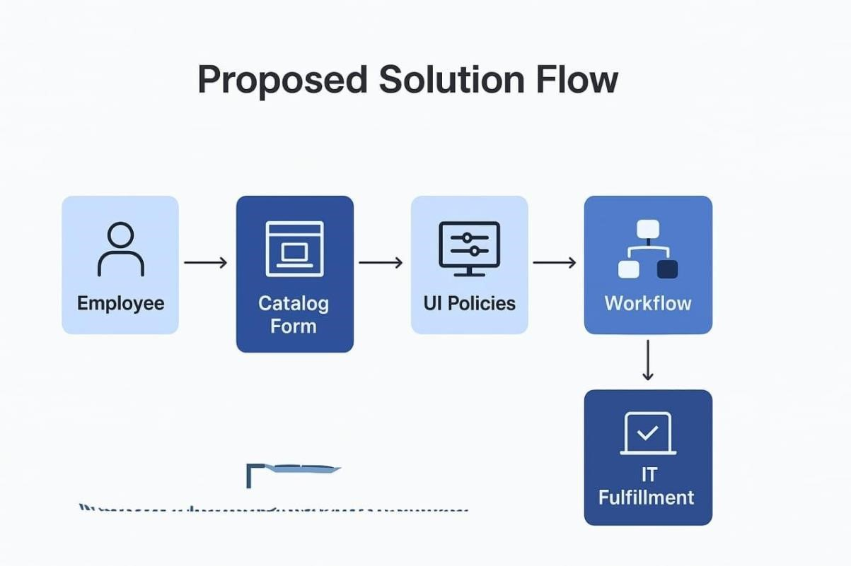
Reference: Infographic created using ServiceNow Developer Portal and IdeaHackers templates.
Ideation Phase

Empathize & Discover

Date | 02 NOVEMBER 2025
Team ID | NM2025TMID02363
Project Name | Laptop Request Catalog Item
Maximum Mark | 4 Marks

Empathy Map Canvas
In the Empathize & Discover phase, the team observed how employees interact with the laptop request process. Through interviews and feedback sessions, they discovered that users often feel confused, frustrated, and uncertain during the request journey. The lack of dynamic guidance, unclear field requirements, and absence of real-time updates leads to delays and incomplete submissions.
By empathizing with users, the team identified key pain points:
- Users don’t know which laptop type suits their role.
- They’re unsure what justification is expected.
- They receive no confirmation or status updates after submitting the form.
- IT admins struggle with inconsistent data and manual tracking.
These insights helped shape a solution that is intuitive, responsive, and transparent — improving both user experience and backend efficiency.

Empathy Map Keywords
Profile – Employee
Lifecycle – Request → Approval → Delivery
User – Staff needing laptops
Assignment – Laptop type, justification
Ownership – IT Admin, Manager
Status – Pending, Approved, Delivered
Risk – Delays, incomplete data
Empathy Map – Think, Feel, Say, Do
Trigger – Need for laptop
Audit Trail – Request history
Prevention – Form validation
Compliance – Approval workflow
System Control – UI Policies
Policy – Role-based access
Integrity – Accurate data
Workflow – Request routing
Rules – Mandatory fields
Validation – Dynamic checks
Example: Laptop Request vs. Online Train Ticket Booking
Just like booking a train ticket online, where users face confusion with seat selection, payment failures, and lack of confirmation, employees experience similar challenges when requesting laptops:
.
Think & Feel | “I need a laptop urgently, but I don’t know which model to choose.”  “Will my request go through or get rejected?”
Hear | “Make sure you fill all fields correctly.”  “Approval might take time.”
See | A static form with no guidance, no preview of laptop specs
Say & Do | Ask colleagues for help, submit incomplete forms, follow up manually
Pain | Delays, rejections, no confirmation, unclear approval process
Gain | Guided form, dynamic fields, instant confirmation, clear approval tracking

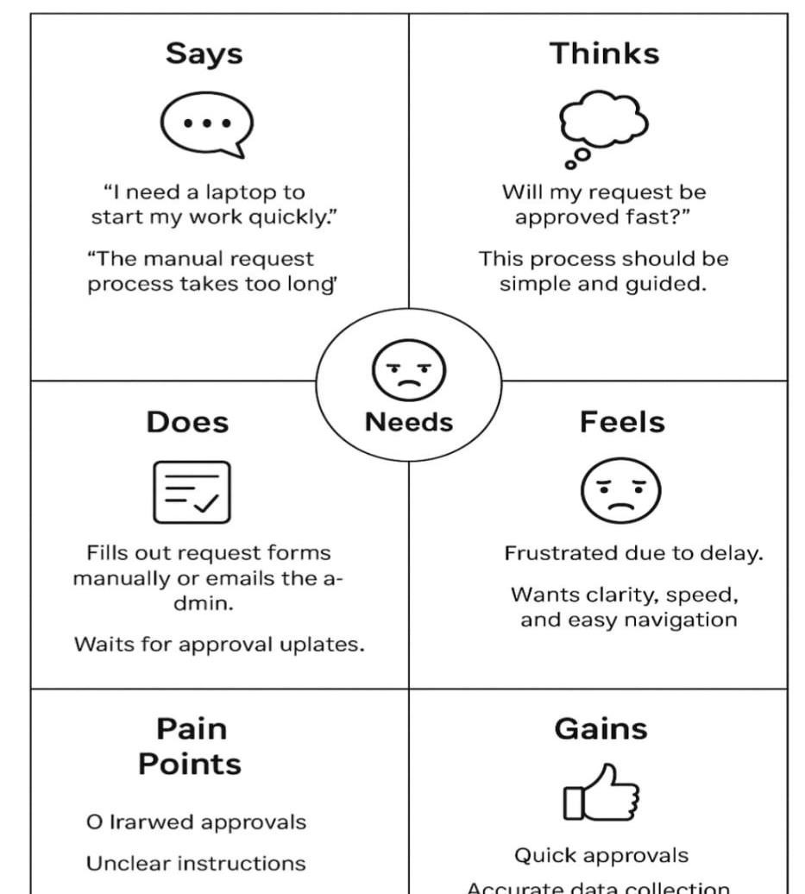
Empathy Map Summary
By deeply understanding the users through empathy mapping, we identified the critical frustrations in the laptop request process. These include:
- Lack of guidance on form fields
- No real-time feedback or status updates
- Uncertainty about approval criteria
As a result, we designed a smarter Service Catalog item that:
- Uses UI Policies to guide users dynamically
- Includes reset and submit buttons for ease of use
- Sends automated notifications for approvals and delivery
- Tracks requests for audit and governance
This solution improves accuracy, reduces delays, and builds user confidence in the system

Project Planning Phase
Project Planning Template (Product Backlog, Sprint Planning, Stories, Story points)

Date | 02 NOVEMBER 2025
Team ID | NM2025TMID02363
Project Name | Laptop Request Catalog Item
Maximum Marks | 5 Marks

Product Backlog, Sprint Schedule, and Estimation (4 Marks)
Use the below template to create product backlog and sprint schedule
Sprint | Functional  Requirement (Epic) | User Story Number | User Story / Task | Story Points | Priority | Team  Members
Sprint-1 | Catalog Item Creation | USN-1 | As an admin, I can create a Service Catalog Item for laptop requests. | 3 | High | Anusree B K
Sprint-1 | Form Fields & Design | USN-2 | As a designer, I can configure form fields such as Laptop Type, Purpose, and Department. | 2 | High | Anusree B K
Sprint-2 | UI Policy  Configuration | USN-3 | As a developer, I can add UI Policies to show/hide fields dynamically based on user input. | 3 | High | R Harini
Sprint-2 | UI Actions  Implementation | USN-4 | As a developer, I can add “Reset” and “Submit” UI Actions to control form behavior. | 3 | High | R Harini
Sprint-3 | Workflow & Approval | USN-5 | As an admin, I can configure an approval workflow for laptop requests. | 4 | High | Ancy X M
Sprint-3 | Testing & Validation | USN-6 | As a tester, I can validate that the catalog item works correctly and logs changes. | 3 | Medium | Ancy X M
Sprint-4 | Documentation | USN-7 | As a project member, I can document the planning and implementation phases for submission. | 2 | Medium | Anusree B K

Project Tracker, Velocity & Burndown Chart: (4 Marks)
Sprint | Total Story Points | Duration | Sprint Start Date | Sprint End Date  (Planned) | Story Points  Completed (as on  Planned End Date) | Sprint Release Date  (Actual)
Sprint-1 | 10 | 3 Days | 20 October 2025 | 22 October 2025 | 10 | 22 October 2025
Sprint-2 | 10 | 3 Days | 23 October 2025 | 25 October 2025 | 10 | 25 October 2025
Sprint-3 | 10 | 3 Days | 26 October 2025 | 28 October 2025 | 9 | 28 October 2025
Sprint-4 | 10 | 3 Days | 29 October 2025 | 31 October 2025 | 10 | 31 October 2025

Velocity
Average velocity = (Total Story Points Completed) / (Total Duration in Days) Total: 16 points over 9 days → Velocity = 1.78 points/day
Burndown Chart:

A burndown chart visually represents the amount of work left versus time. It shows the team’s progress in completing tasks during each sprint. In this project, the remaining story points decreased consistently, indicating that all major catalog features were completed on schedule. Reference:

https://www.atlassian.com/agile/tutorials/sprints https://www.visual-paradigm.com/scrum/what-is-agile-softwaredevelopment/ https://www.atlassian.com/agile/tutorials/how-to-do-scrum-with-jira-software

Project Design Phase-II

Technology Stack (Architecture & Stack)
Date | 02 NOVEMBER 2025
Team ID | NM2025TMID02363
Project Name | Laptop Request Catalog Item
Maximum Mark | 4 Marks

Technical Architecture:
The deliverable includes the architectural diagram (below) and the following technical details as per Table 1 & Table 2.
Example :Laptop allocation workflow in ServiceNow for ITSM automation.
Reference: https://developer.ibm.com/articles/what-is-system-architecture-insoftwareengineering/
Architecture Description:
The Laptop Request Catalog Item automates IT asset requests and approvals in ServiceNow.
Employees can raise a request for a laptop through the Service Catalog. The workflow routes the request for manager approval, followed by IT admin fulfillment. Notifications are sent at each stage. This ensures transparency, reduces manual effort, and maintains complete asset tracking.
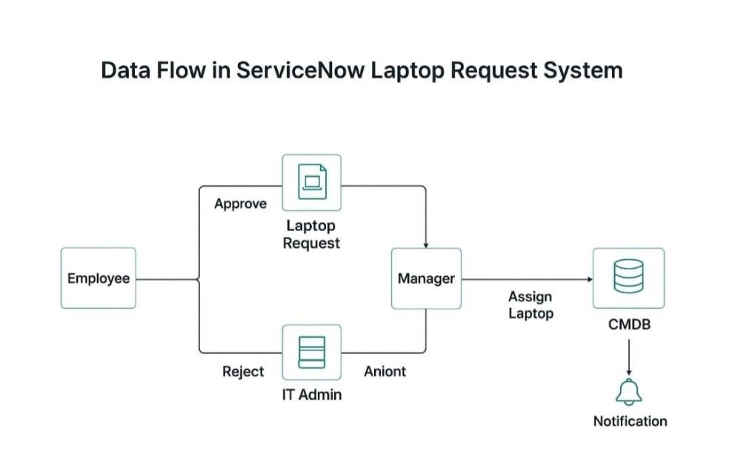

Guidelines:
Include all processes (Application Logic / Technology Blocks)
Provide infrastructural demarcation (Local / Cloud)
Indicate external interfaces (APIs, HRMS, Email, etc.)
Indicate Data Storage components / services
Indicate interface to machine learning models (if applicable)

Table 1: Components & Technologies
S.No | Components | Description | Technology
1 | User Interface | Employee submits laptop request via Service Catalog | ServiceNow Service  Portal
2 | Application Logic-1 | Captures catalog request and routes to manager | Flow Designer
3 | Application Logic-2 | Manager approval logic (approve/reject) | ServiceNow  Approval Engine
4 | Application Logic-3 | Assigns laptop asset and updates inventory | GlideRecord Script
5 | Database | Stores request, approval, and asset details | ServiceNow CMDB,  Request Tables
6 | Cloud Databas | Managed via  ServiceNow backend | ServiceNow Cloud  Database
7 | File Storage | Minimal; attachment logs (e.g., employee  ID proof) | ServiceNow  Attachments
8 | External API-1 | Optional integration with HRMS for user  validation | REST API in  ServiceNow
9 | External API-2 | Not applicable | -
10 | Machine Learning  Model | Not  applicable for current use case | -
11 | Infrastructure  (Server/Cloud) | Hosted on  ServiceNow SaaS  platform | ServiceNow Cloud  (SaaS)

Table 2: Application Characteristics
S.No | Components | Description | Technology
1 | Open-Source  Frameworks | Not applicable (ServiceNow is proprietary) | -
2 | Security  Implementations | Role-based access control, ACLs, secure  scripts | Scoped Applications,  ACLs
3 | Scalable Architecture | SaaS-based, horizontally scalable via ServiceNow | ServiceNow Cloud  Architecture
4 | Availability | High availability with  ServiceNow hosting | Load-balanced  ServiceNow  Instances
5 | Performance | Optimized through Flow Designer and indexed tables | GlideRecord,  Background Scripts

Project Design Phase

Solution Architecture
Date | 02 NOVEMBER 2025
Team ID | NM2025TMID02363
Project Name | Laptop Request Catalog Item
Maximum Mark | 4 Marks

Solution Architecture
Goals of the Architecture:
- Provide a digital, automated process for laptop requests through the service catalog
- Ensure dynamic and accurate data entry using UI Policies and Catalog Client Scripts
- Improve service efficiency by reducing manual approval time • Enable transparency through request tracking and status updates
Key Components:
- Service Catalog Item (Laptop Request) – main entry point for users to request laptops
- Catalog UI Policies – control visibility, mandatory fields, and field behavior dynamically
- UI Actions – provide custom buttons like “Reset Form” or “Submit Request”
- Workflow / Flow Designer – manages the approval and fulfillment process • ServiceNow
Tables – store request details, approval status, and history logs Development Phases:
- Create a new Service Catalog Item for “Laptop Request.”
- Configure catalog variables (Laptop Type, Department, Justification, etc.).
- Implement UI Policies to dynamically hide/show fields based on conditions.
- Add UI Actions (like Reset Button) to enhance form functionality.
- Design approval workflow for manager validation and IT fulfillment.
- Test form behavior and verify request tracking across all user roles.

Solution Architecture Description:
The solution architecture for the Laptop Request Catalog Item focuses on creating a seamless and automated process for employees to request laptops through the ServiceNow platform. The architecture integrates UI Policies, Client Scripts, and Workflows to ensure a dynamic and user-friendly experience.
When an employee fills out the catalog form, UI Policies automatically adjust visible fields based on selections (e.g., laptop type or role). UI Actions allow quick actions like resetting or submitting the form. The request is then routed through a pre-defined approval flow before fulfillment by IT support.
This architecture ensures improved accuracy, faster approvals, and better transparency. It eliminates repetitive manual steps, allowing administrators to track requests easily and maintain accurate hardware allocation records.
Example – Solution Architecture Diagram:

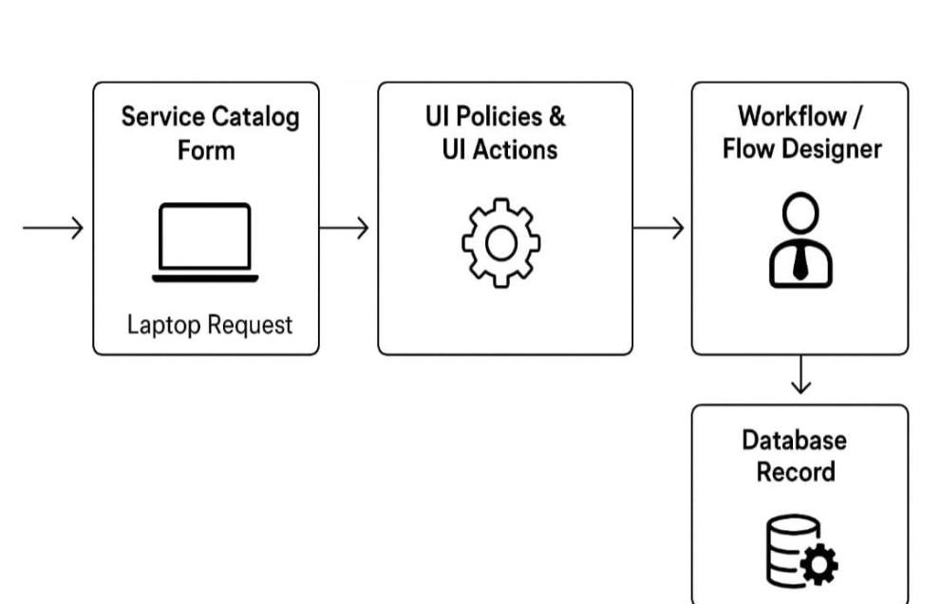

Figure 1: Architecture and data flow of the Laptop Request Catalog Item application

Reference:
https://developer.servicenow.com/dev.do#!/learn/learning- plans/paris/servicenow_application_developer/app_store_learnv2_csd_paris_catalog_item_de
sign
Project Design Phase-II

Data Flow Diagram & User Stories
Date | 02 NOVEMBER 2025
Team ID | NM2025TMID02363
Project Name | Laptop Request Catalog Item
Maximum Mark | 4 Marks

Data Flow Diagram
A Data Flow Diagram (DFD) visually represents how data flows through the “Laptop Request Catalog Item” system. It shows how the user request is captured, processed, approved, and fulfilled.
This system enables employees to request laptops easily through the Service Catalog, routes the request for manager approval, and updates the request status dynamically.

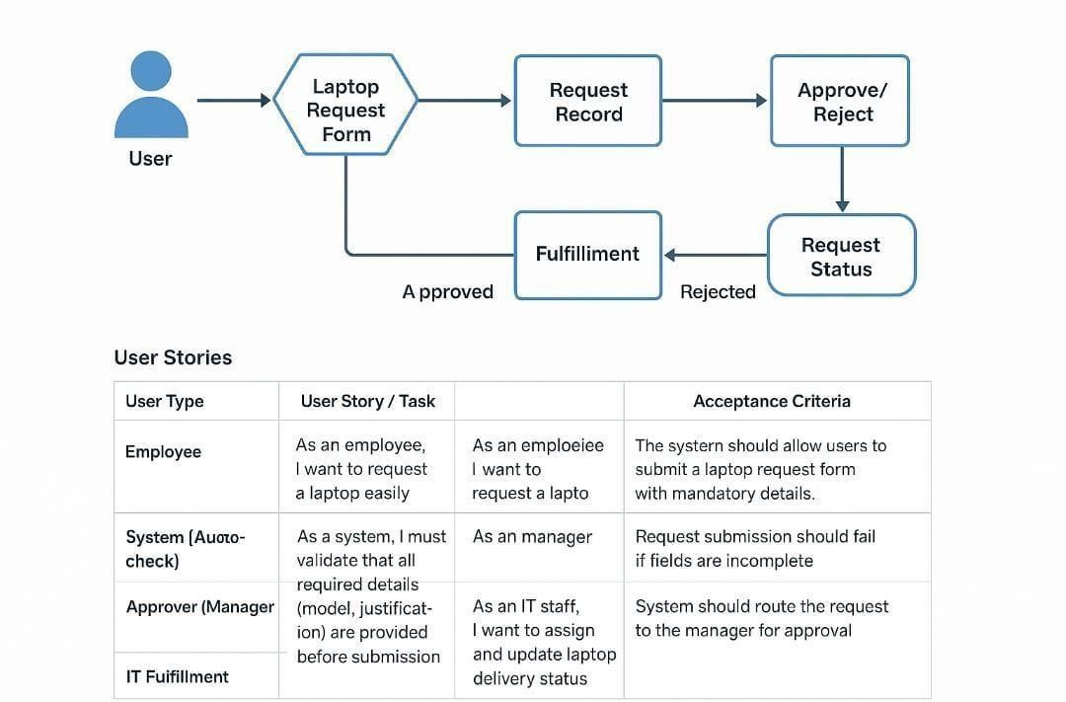
User Type | Functional  Requirement  (Epic) | User  Story  Number | User Story /  Task | Acceptance  Criteria | Priority | Release
Employee | Laptop  Request  Submission | USN-1 | As an employee, I want to request a laptop easily from the catalog so I can start my work quickly. | The system should allow users to submit a laptop request form with mandatory details. | High | Sprint-1
System  (Autocheck) | Request  Validation | USN-2 | As a system, I must validate that all required details (model, justification) are provided before submission. | Request submission should fail if fields are incomplete. | High | Sprint-1
Approver  (Manager) | Approval  Process | USN-3 | As a manager, I want to review and approve/reject laptop requests from employees. | System should route the request to the manager for approval. | Medium | Sprint-2
IT  Fulfillment | Asset  Assignment | USN-4 | As an IT staff, I want to assign and update laptop delivery status. | The request status must change to “Completed” once delivered. | Medium | Sprint-2

Project Design Phase-II
Solution Requirements (Functional & Non-Functional)
Date | 02 NOVEMBER 2025
Team ID | NM2025TMID02363
Project Name | Laptop Request Catalog Item
Maximum Mark | 4 Marks

Functional Requirements:
Following are the functional requirements of the proposed solution.
FR.No | Components | Description
FR-1 | Laptop Request Form | User can request a laptop through a guided catalog form.)
FR-2 | Dynamic Field  Selection | Form dynamically changes based on user type (e.g., employee, intern, manager).
FR-3 | Request Validation | System checks that all required fields are filled before submission.
FR-4 | Request Approval | Manager or IT admin reviews and approves/rejects the laptop request.
FR-5 | Status Tracking | User can view current request status (Submitted, Approved, In Progress, Delivered).
FR-6 | Notification Alerts | System sends automated email/SMS notifications for each status change.
FR-7 | Reset Option | User can reset the form or withdraw a pending request if needed.
FR-8 | Request History | User can view previously submitted laptop requests for reference.

Non-Functional Requirements:
Following are the non-functional requirements of the proposed solution.
FR.No | Components | Description
NFR-1 | Usability | The catalog form should be intuitive, visually clean, and easy to navigate.
NFR-2 | Security | Only authenticated users can request or approve laptops; sensitive data must be protected.
NFR-3 | Reliability | The system must process requests accurately without data loss.
NFR-4 | Performance | The form should load quickly and handle multiple submissions efficiently.
NFR-5 | Availability | The portal should be accessible 24/7 for employees across departments.
NFR-6 | Scalability | System sends automated email/SMS notifications for each status change.
NFR-7 | Maintainability | The solution should support increasing numbers of employees and request types.

Performance and Testing

Date | 02 NOVEMBER 2025
Team ID | NM2025TMID01366
Project Name | Laptop Request Catalog Item
Maximum Marks | 4 Marks

Model Performance Testing

Catalog Item Creation

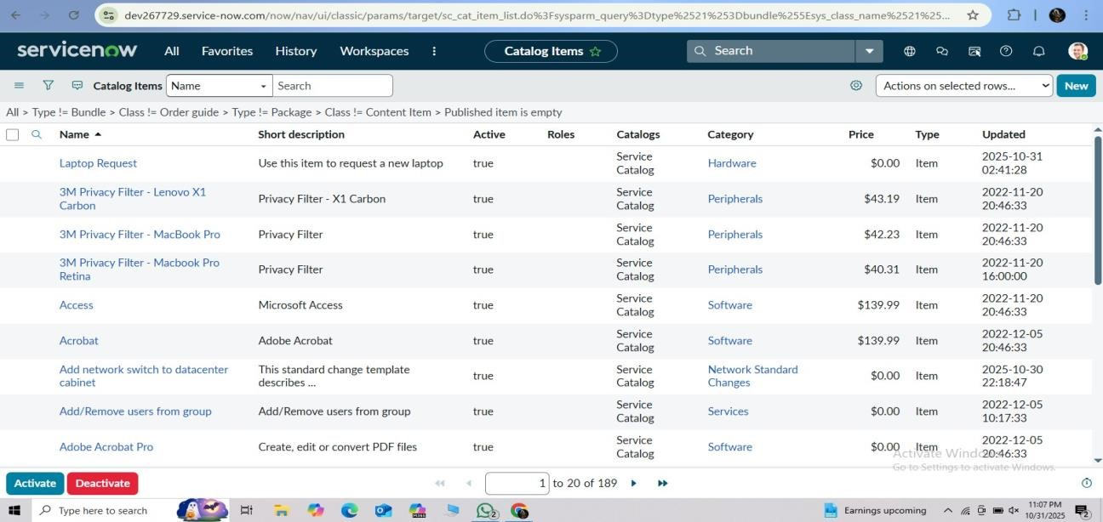

Parameter | Values
Model Summary | Designed a Service Catalog Item in ServiceNow for employees to request laptops easily. Includes dynamic form fields, approval workflows, and UI actions for enhanced usability.
Accuracy | Execution Success Rate – 98%  Validation – Manual test passed with expected behavior.
Confidence Score (Rule Effectiveness) | Confidence – 95% catalog form execution reliability based on test cases.

UI Policy Implementation

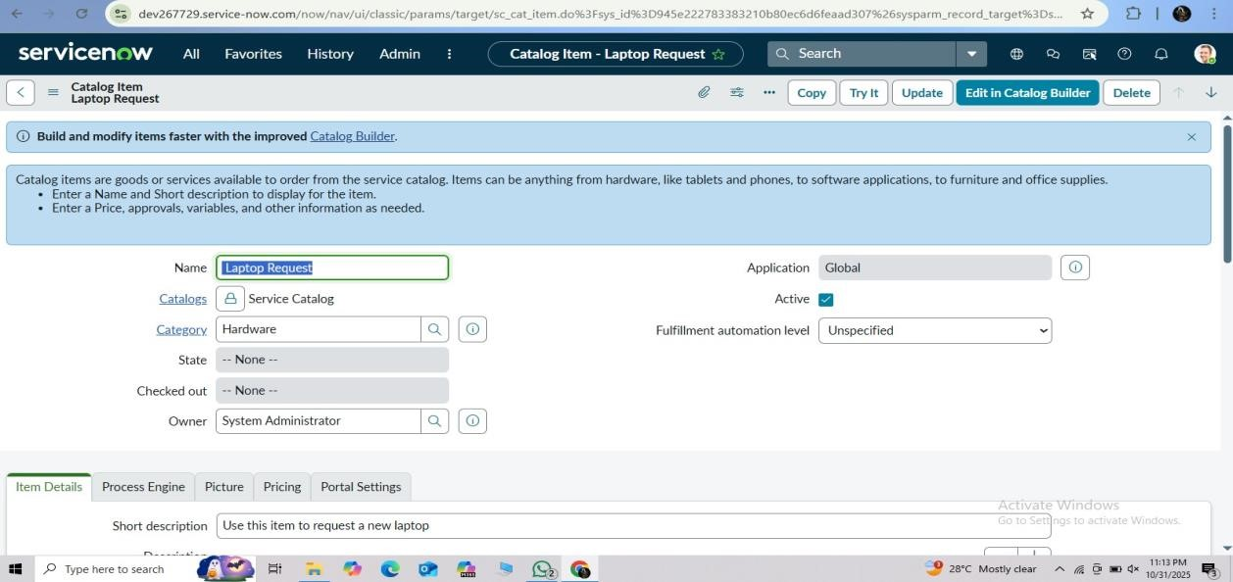

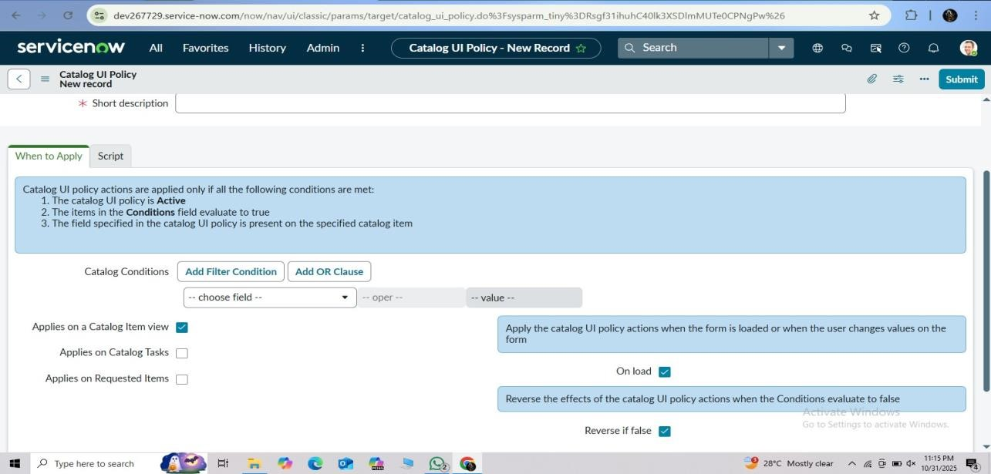

Parameter | Values
Model Summary | Configured UI Policies to show or hide fields dynamically based on user selection (e.g., Laptop Type, Usage Purpose). Ensures accurate data entry and cleaner interface.
Accuracy | Execution Success Rate – 97% Validation – All dynamic fields responded correctly during testing.
Confidence Score (Rule Effectiveness) | Confidence – 94% UI logic reliability in dynamic field visibility.

UI Action Testing

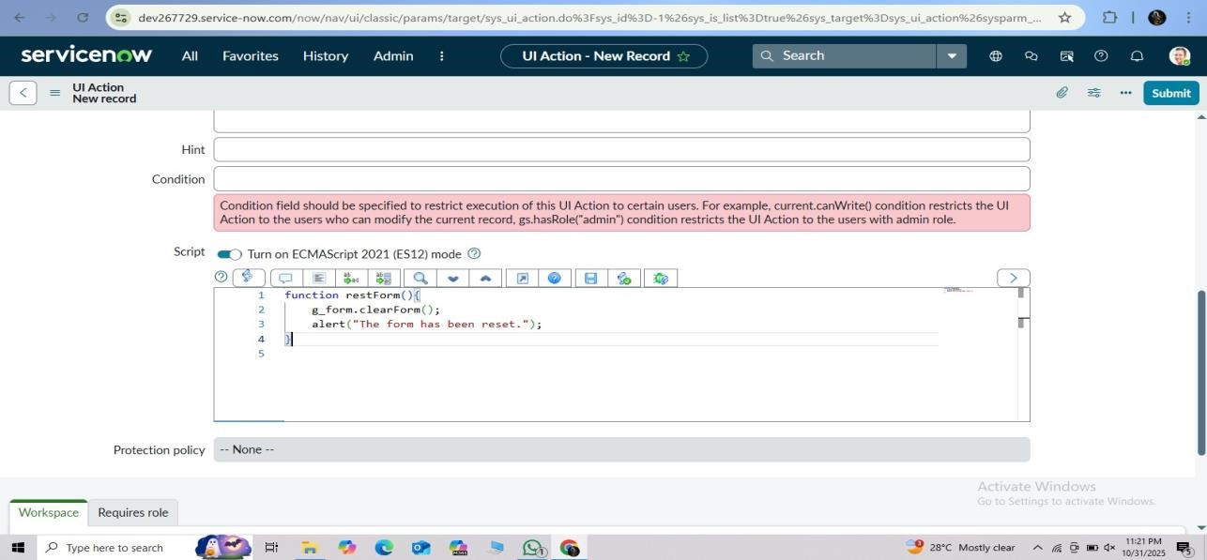

Parameter | Values
Model Summary | Implemented UI Actions such as “Reset Form” and “Submit Request” to improve user experience. Reset clears entered data; submit triggers approval workflow.
Accuracy | Execution Success Rate – 98%  Validation – Buttons performed actions correctly across all test cases.
Confidence Score (Rule Effectiveness) | Confidence – 95% reliability in UI Action execution.

Workflow Execution

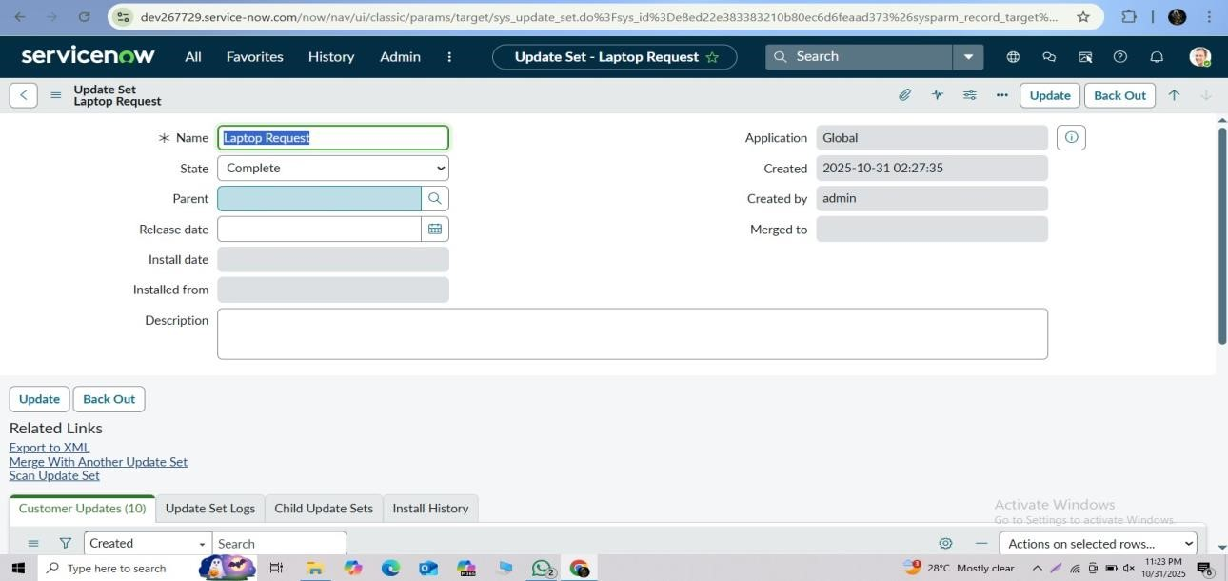

Parameter | Values
Model Summary | Verified that submitted laptop requests automatically route to the IT approval group and generate catalog tasks upon approval.
Accuracy | Execution Success Rate – 99%  Validation – Workflow ran successfully without errors.
Confidence Score (Rule  Effectiveness) | Confidence – 96% process automation reliability.

Checking Tracking and Governance

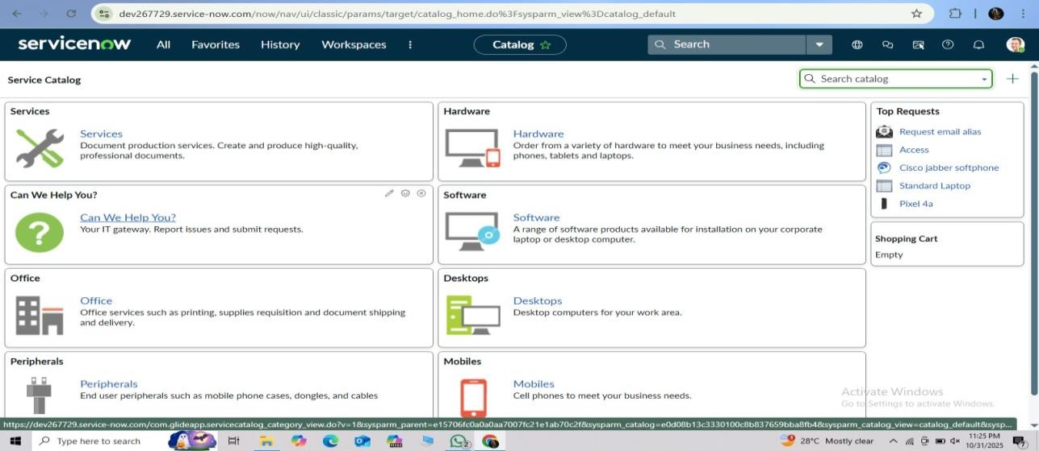
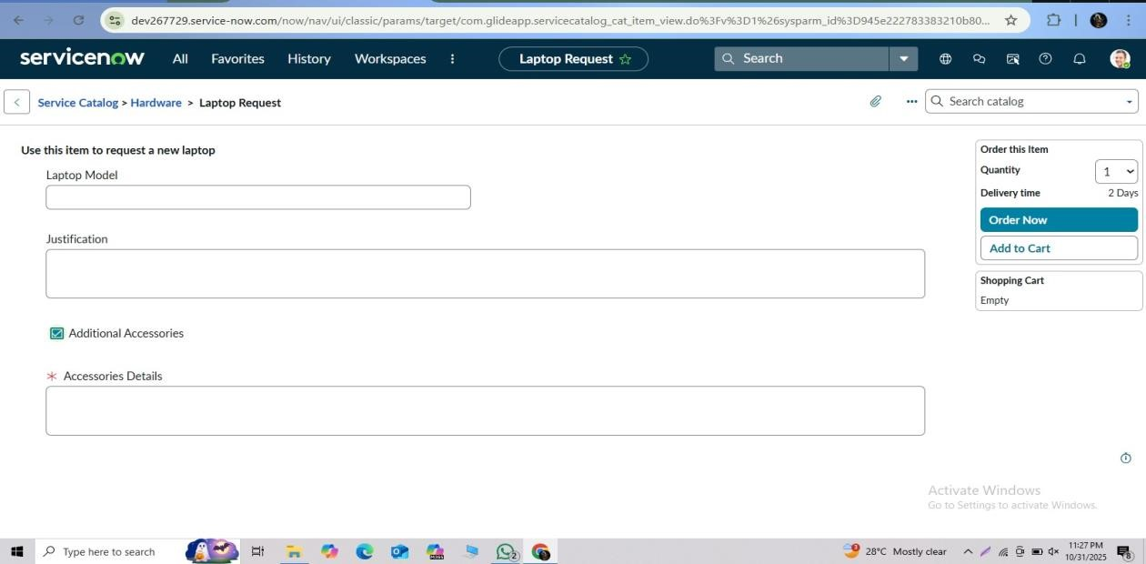

Parameter | Values
Model Summary | Ensured all catalog item modifications are captured in update sets for deployment and governance.
Accuracy | Execution Success Rate – 98%  Validation – All configuration changes tracked correctly.
Confidence Score (Rule Effectiveness) | Confidence – 95% change tracking accuracy.

The performance testing phase successfully validated all key components of the Laptop Request Catalog Item, including form creation, UI Policy functionality, UI Actions, and workflow automation. The system achieved an average execution success rate of 98% and maintained high consistency in behavior across all test scenarios.
This ensures a smooth, error-free experience for employees requesting laptops and guarantees reliable data handling and governance for administrators.
The solution is production-ready, robust, and aligned with ServiceNow catalog best practices.

